Create a bot that can invite affliator’s on TikTok shop for me

Create Invitation Link from target collaboration

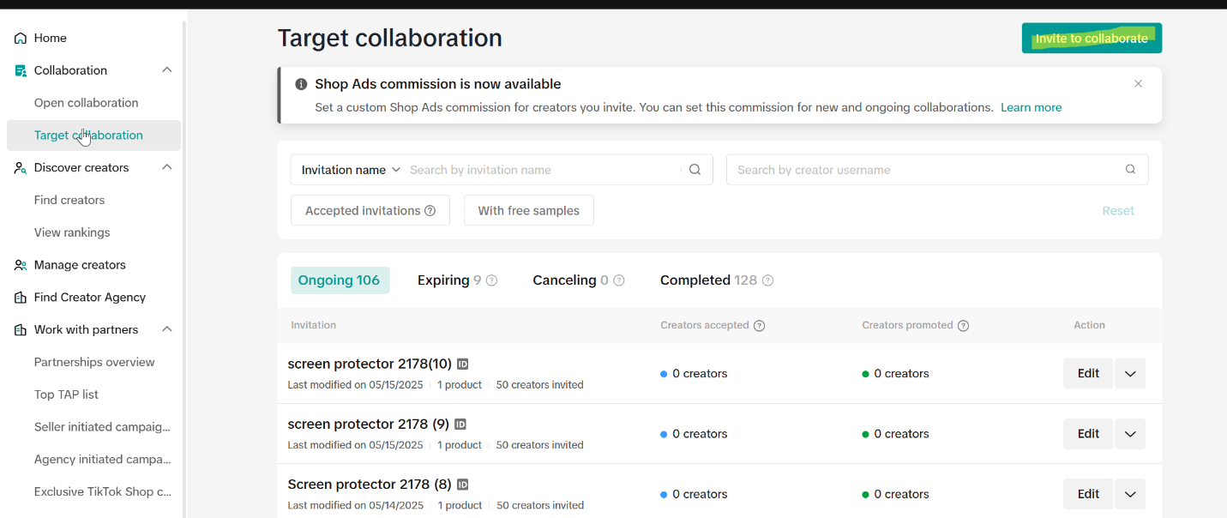

make a preset name e.g "Promotion product 1"(in each link the Bot can invite 50 creators) and create invitations for this product up to a set number so if i want 300 invites for this product i would need 6 invitation links and there would be "Promotion product 1-6" Each link's validation period should be one month from the creation date

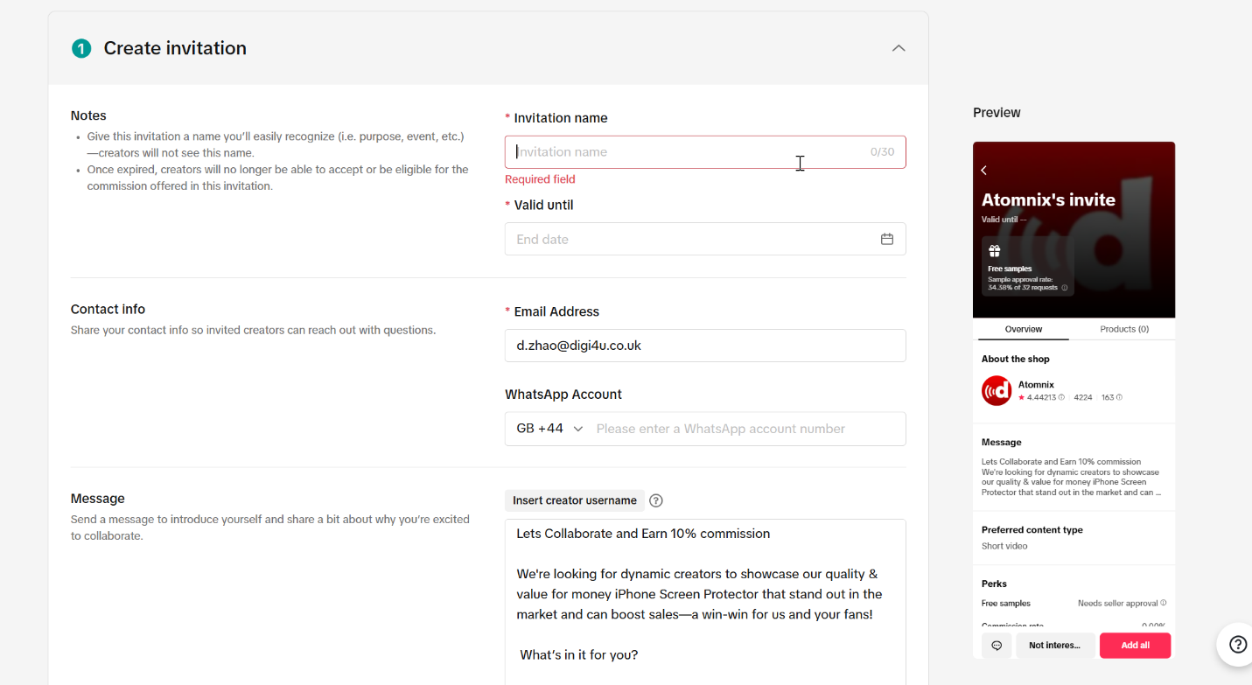

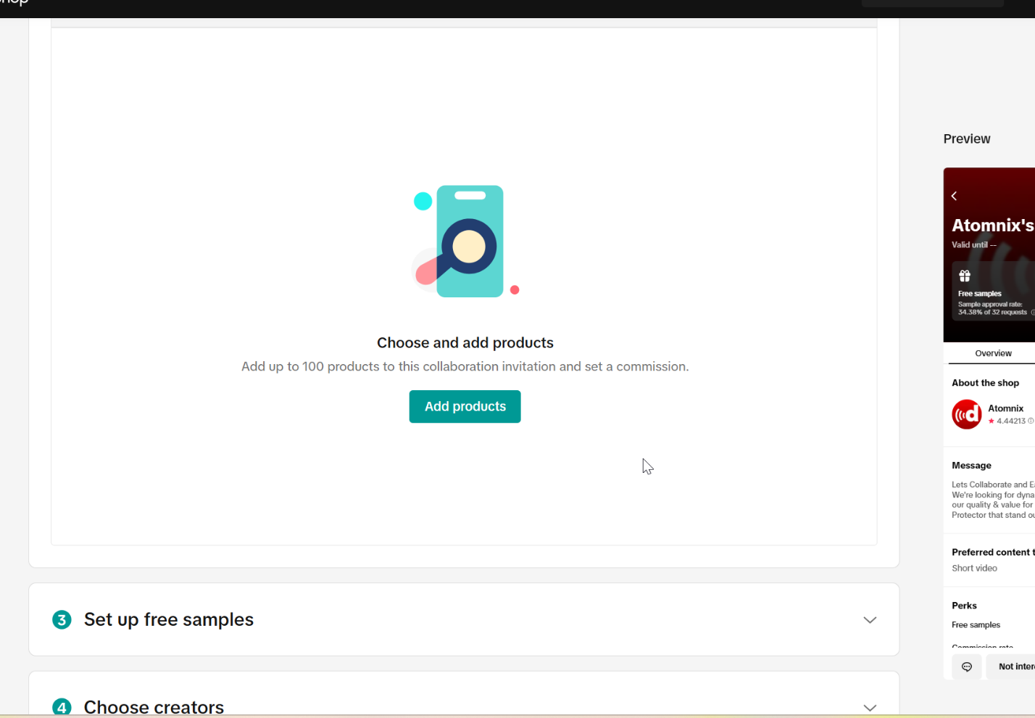

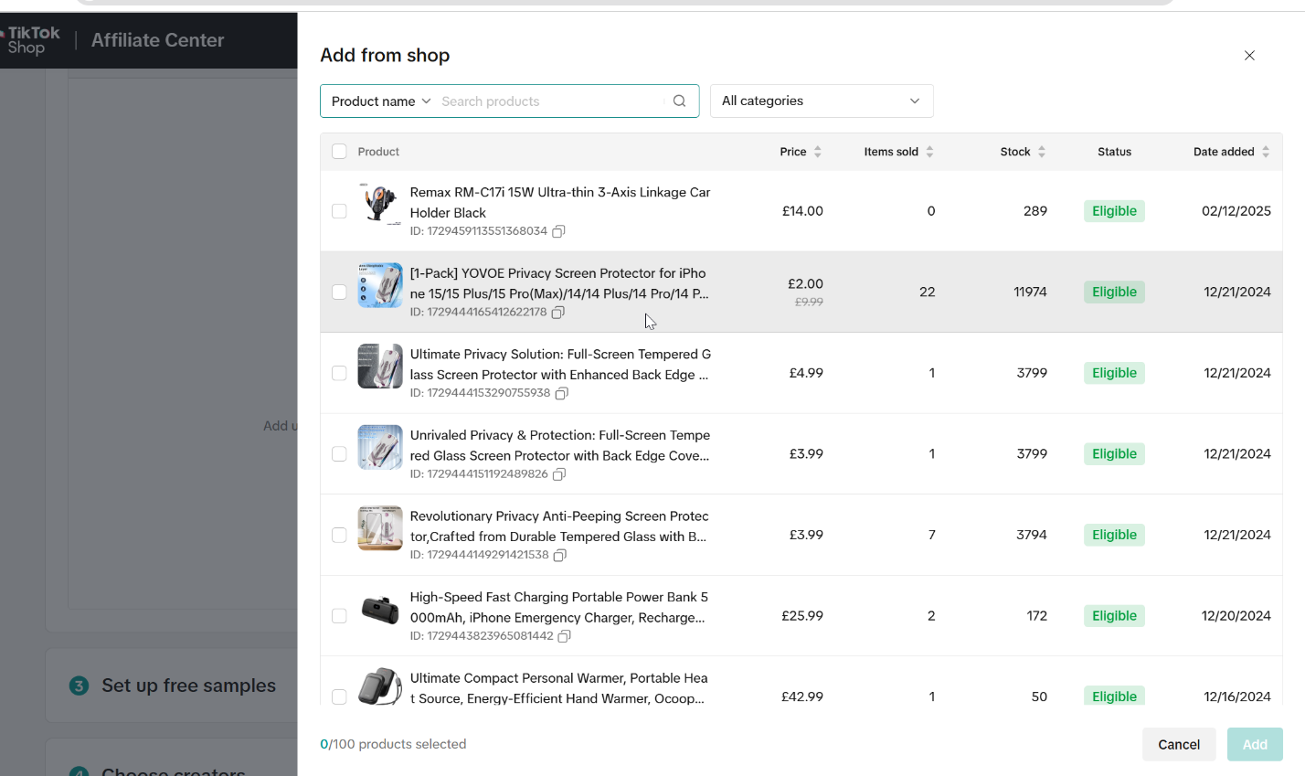

here the Bot would need to add product to the invitation link

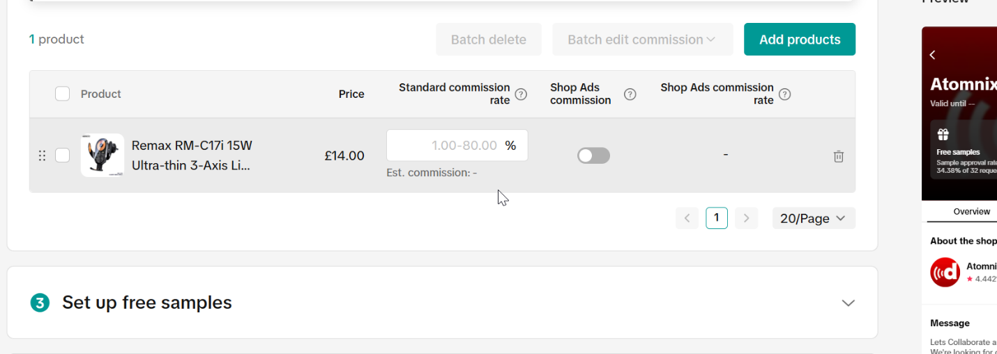

set standard commission to 10%



select manual review requests

to activate this, the Bot would need to invite a new creator in the choose creators

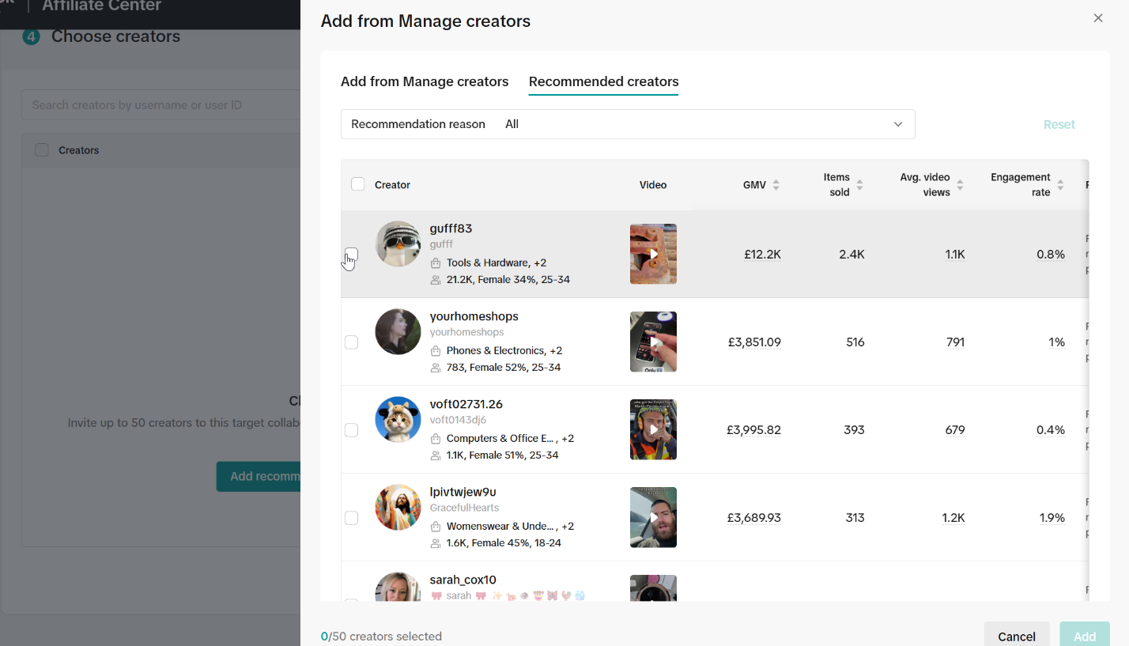

choose an random one but sometimes if they ‘be been invited before the Bot need to choose another one

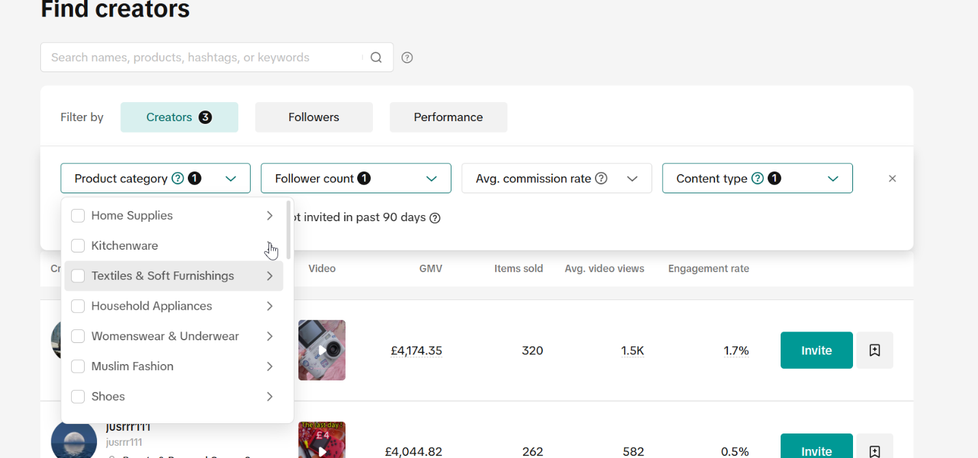

after those then it comes the invite where we need to first choose an invite category

then a follower count

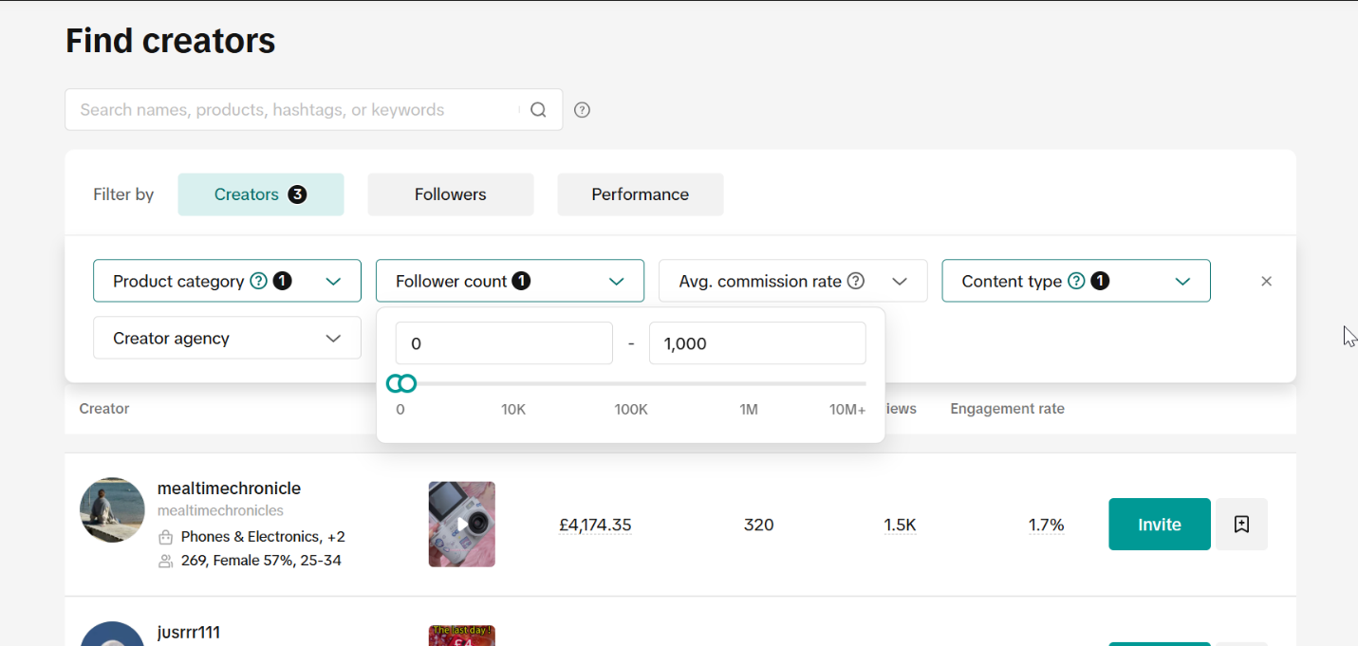

preferably we'd like to invite up to 1m followers 0-1m but that might get too laggy for the website so if the Bot can make it not lag do 0-1m if not the Bot need to go in increments from 0-1k then 1k-2k something like that

and the Bot need to end the script when the GMV of the creators hits a certain point

this should be all the things the bot should do

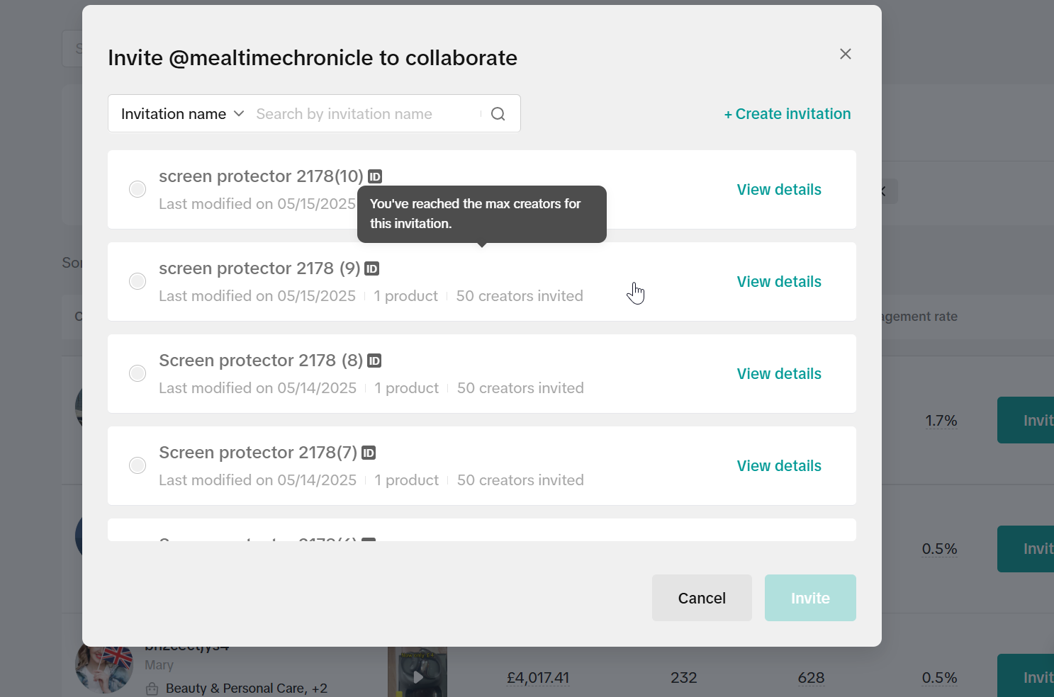

when the Bot click invite the Bot have to select the invite links the Bot've made